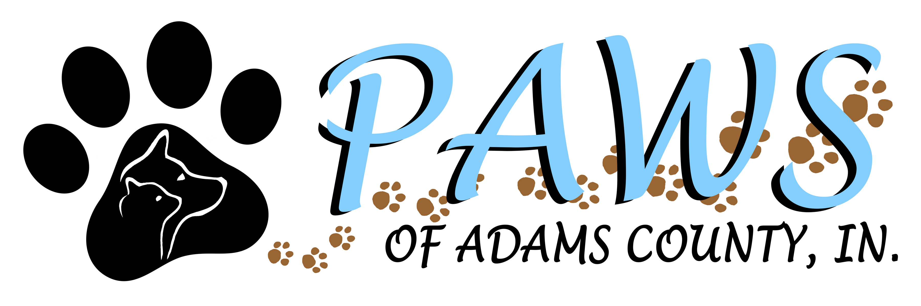
Paws of Adams County Intake Form

Surrender's Name: _________________________________________ Date___________
Address: _________________________ City: ___________ State: _____ Zip: _________
Phone: __________________ Cell: ________________ email: _____________________
Donation to PAWS/ Intake fee: __________________________________

*******************************************************************************************
Pet Information:

Pet name: _______________________ Sex: ____ Birth Date: __________ Age: _____ Microchipped? ______
Personal pet / Found / Other: ________________________________________
Reason surrendered: ____________________________________________________________________
Location Found if applicable: ______________________________________________________________
Brand of food currently on _________________________________
Breed: __________________ Color/ Description: _____________________________________________
Spayed/ Neutered Yes / No Housebroke: Yes / No / Partially Crate Trained: Yes / No
Good with cats: ______ Good with Dogs: _______ Good with children: _______ Good with adults: _______
Any fears/ aggression / dislikes / behavioral issues:
______________________________________________________________________________________
Has your animal ever bit anyone? __________________

Where did you get pet? Breeder / Shelter / Pet store / Friend / Free pet ad / your pet's litter / Stray / Other:
______________________________________________________________________________
How long have you had pet? ______________________________________
Pet health problems? ____________________________________________
Pet's vet: __________________ Address: _____________________Phone: _____________________
Vaccines? what / when/ where: _______________________________________________________
Rabies: when / where: _______________________________________________________________
HW preventative (when last/ how often): ______________________
Flea preventative (what / when): _____________________________
Types / Brands of pet food: ___________________________________________________________
Pet Notes: _________________________________________________________________________

I certify that the answers that are provided here are true to the best of my knowledge and that I am the owner/ finder of said pet. I do hereby release custody/ ownership of this animal into the care of PAWS of Adams County Indiana animal Rescue. At the signing of this form Paws will have complete and sole custody of this animal. Paws will have pet updated on vetting as well as spayed or neutered, if needed. Pet will be put up for adoption and adopted out into a secure loving home to the best of our ability.
Surrender's signature: _________________________________________________ Date ________
PAWS Agent Signature: ________________________________________________ Date ________

Updated 2/20/2020

